# Exercises: Abstraction

This document defines the exercises for ["Java Advanced" course @ Software University](https://softuni.bg/courses/java-advanced). Please submit your solutions (source code) of all below described problems in [Judge](https://judge.softuni.bg/Contests/776).

## Fill the Matrix

Filling a matrix in the regular way (**top to bottom** and **left to right**) is boring. Write two **methods** that **fill** a **matrix** of size **N x** N in **two** different **patterns.** Both patterns are described below:

| **Pattern A** | **Pattern B** |
| --- | --- |
|  |  |

### Examples

|  |  |
| --- | --- |
| **Input** | **Output** |
| 3, A | 1 4 7  2 5 8  3 6 9 |
| 3, B | 1 6 7  2 5 8  3 4 9 |

### Hints

* Make a different method for each pattern
* Make a method for printing the matrix

## Matrix of Palindromes

Write a program to generate the following **matrix of palindromes** of **3** letters with **r** rows and **c** columns like the one in the examples below.

* **Rows** define the first and the last letter: row 0 🡪 ‘a’, row 1 🡪 ‘b’, row 2 🡪 ‘c’, …
* **Columns + rows** define the middle letter:
  + column 0, row 0 🡪 ‘a’, column 1, row 0 🡪 ‘b’, column 2, row 0 🡪 ‘c’, …
  + column 0, row 1 🡪 ‘b’, column 1, row 1 🡪 ‘c’, column 2, row 1 🡪 ‘d’, …

### Input

* The numbers r and c stay at the first line at the input.
* r and c are integers in the range [1…26].
* r + c ≤ 27

### Examples

|  |  |
| --- | --- |
| **Input** | **Output** |
| 4 6 | aaa aba aca ada aea afa  bbb bcb bdb beb bfb bgb  ccc cdc cec cfc cgc chc  ddd ded dfd dgd dhd did |
| 3 2 | aaa aba  bbb bcb  ccc cdc |

### Hints

* Use two nested loops to generate the matrix.
* Print the matrix row by row in a loop.
* Don’t forget to pack everything in methods.

## Diagonal Difference

Write a program that finds the **difference between the sums of the square matrix diagonals** (absolute value).

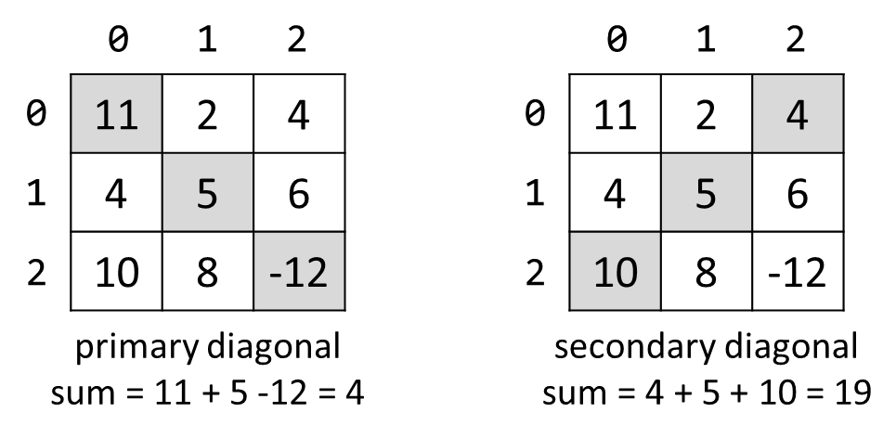

### Input

* The **first line** holds a number n – the size of matrix.
* The next n **lines** hold the **values for every row** – n numbers separated by a space.

### Examples

|  |  |  |
| --- | --- | --- |
| **Input** | **Output** | **Comments** |
| 3  11 2 4  4 5 6  10 8 -12 | 15 | **Primary diagonal:** sum = 11 + 5 + (-12) = 4  **Secondary diagonal:** sum = 4 + 5 + 10 = 19  **Difference:** |4 - 19| = 15 |

### Hints

* Use a **single** loop i = [1 … n] to sum the diagonals.
* The **primary diagonal** holds all cells {row, col} where row == col == i.
* The **secondary diagonal** holds all cells {row, col} where row == i and col == n-1-i.

## 2x2 Squares in Matrix

Find the count of **2 x 2 squares of equal chars** in a matrix.

### Input

* The matrix size is given at the first row (**rows** and **columns**).
* Matrix characters come at the next **rows** lines (space separated).

### Examples

|  |  |  |
| --- | --- | --- |
| **Input** | **Output** | **Comments** |
| 3 4  A B B D  E B B B  I J B B | 2 | Two 2 x 2 squares of equal cells:  A **B B** D A B B D  E **B B** B E B **B B**  I J B B I J **B B** |
| 2 2  a b  c d | 0 | No 2 x 2 squares of equal cells exist. |

### Hints

* Check all possible 2 x 2 squares for equal elements.
* Make sure your program wouldn’t throw an **IndexOutOfBoundsException()**

## Maximal Sum

Write a program that reads a rectangular integer matrix of size **N x M** and finds in it the square **3 x 3** that **has maximal sum of its elements**.

### Input

* On the first line, you will receive the rows **N** and columns **M**.
* On the next **N lines** you will receive **each row with its elements**.

Print the **elements** of the 3 x 3 square as a matrix, along with their **sum**. See the format of the output below:

### Examples

|  |  |  |
| --- | --- | --- |
| **Input** | **Output** | **Comments** |
| 4 5  1 5 5 2 4  2 1 4 14 3  3 7 11 2 8  4 8 12 16 4 | Sum = 75  1 4 14  7 11 2   1. 12 16 |  |

## Sequence in Matrix

You are given a matrix of strings of size**N x M**. Sequences in the matrix are defined as sets of several neighbour elements, located on the same **line, column or diagonal**. Write a program that finds the longest sequence of equal strings in the matrix.

If there are **two sequences with the same length**, **print the one that you found last** (if you start from the upper left element).

### Input

* On the first line, you will receive the rows **N** and columns **M**.
* On the next **N lines** you will receive **each row with its elements**.

### Examples

| **Input** | **Output** | **Comments** |
| --- | --- | --- |
| 3 4  ha fifi ho hi  fo ha hi xx  xxx ho ha xx | ha, ha, ha |  |
| 3 3  s qq s  pp pp s  pp qq s | s, s, s |  |

## Collect the Coins

Working with multidimensional arrays can be (and should be) fun. Let's make a game out of it.

You receive the layout of a **board** from the console. Assume it will always have **4 rows** which you'll get as strings, each on a separate line. Each character in the strings will represent a **cell** on the board. Note that the strings may be of different lengths.

You are the player and start at the **top-left** corner (that would be position **[0, 0]** on the board). On the fifth line of input you'll receive a string with movement commands which tell you where to go next, it will contain only these four characters – '**>**' (move **right**), '**<**' (move **left**), '**^**' (move **up**) and '**v**' (move **down**).

You need to keep track of two types of events – collecting **coins** (represented by the symbol '**$**', of course) and hitting the **walls** of the board (when the player tries to move off the board to **invalid** coordinates). When all moves are over, **print the amount of money** collected and the **number of walls hit**.

### Examples

|  |  |  |
| --- | --- | --- |
| **Input** | **Output** | **Comments** |
| Sj0u$hbc  $87yihc87  Ewg3444  $4$$  V>>^^>>>VVV<< | Coins collected: 2  Walls hit: 2 | Starting from (0, 0), move down (coin), twice right, up, up again (wall), three times right (coin on second move), twice down, down again (wall), twice to the left – game over (no more moves). Total of two coins collected and two walls hit in the process. |

### Hints

* Think about Exception Handling

## Matrix shuffling

Write a program which reads a string matrix from the console and performs certain operations with its elements. User input is provided in a similar way like in the problems above – first you read the **dimensions** and then the **data**.

Your program should then receive commands in format: "**swap row1 col1 row2c col2**" where row1, row2, col1, col2 are **coordinates** in the matrix. In order for a command to be valid, it should start with the "**swap**" keyword along with **four valid coordinates** (no more, no less). You should **swap the values** at the given coordinates (cell [row1, col1] with cell [row2, col2]) **and print the matrix at each step** (thus you'll be able to check if the operation was performed correctly).

If the **command is not valid** (doesn't contain the keyword "swap", has fewer or more coordinates entered or the given coordinates do not exist), print "**Invalid input!**" and move on to the next command. Your program should finish when the string "**END**" is entered.

### Examples

|  |  |
| --- | --- |
| **Input** | **Output** |
| 2 3  1 2 3  4 5 6  swap 0 0 1 1  swap 10 9 8 7  swap 0 1 1 0  END | 5 2 3  4 1 6  Invalid input!  5 4 3  2 1 6 |
| 1 2  Hello World  0 0 0 1  swap 0 0 0 1  swap 0 1 0 0  END | Invalid input!  World Hello  Hello World |

### Hints

* Think about Exception Handling

## * Terrorists Win!

On de_dust2 terrorists have planted a bomb (or possibly several of them)! Write a program that sets those bombs off!

A bomb is a string in the format **|...|**. When set off, the bomb destroys all characters inside. The bomb should also destroy **n** characters to the left and right of the bomb. **n** is determined by the **bomb** **power** (the **last digit of the ASCII sum** of the characters inside the bomb). Destroyed characters should be replaced by '**.**' (dot). For example, we are given the following text:

**prepare|yo|dong**

The bomb is **|yo|**. We get the bomb power by calculating the last digit of the sum: **y** (121) + **o** (111) = 23**2**. The bomb explodes and destroys itself and **2** characters to the left and **2** characters to the right. The result is:

**prepa........ng**

### Input

The input data should be read from the console. On the first and only input line you will receive the text.

The input data will always be valid and in the format described. There is no need to check it explicitly.

### Output

The destroyed text should be printed on the console.

### Constraints

* The lengthof the text will be in the range [1...1000].
* The bombs will hold a number of characters in the range [0…100].
* Bombs will not be nested (i.e. bomb inside another bomb).
* Bomb explosions will never overlap with other bombs.
* Time limit: 0.3 sec. Memory limit: 16 MB.

### Examples

|  |  |
| --- | --- |
| **Input** | **Output** |
| prepare|yo|dong | prepa........ng |
|  |  |
| **Input** | **Ouput** |
| de_dust2 |A| the best |BB|map! | de_d.............bes........p! |

## * Plus-Remove

You are given a sequence of **text lines**, holding symbols, small and capital Latin letters. Your task is to **remove all "plus shapes"** in the text. They may consist of small and capital letters at the same time, or of any symbol. All of the **X shapes** below are **valid**:

|  |  |  |  |  |  |  |
| --- | --- | --- | --- | --- | --- | --- |
| a  aaa  a | B  BBB  B | T  TtT  T | p  PPp  P | &  &&&  & | *  ***  * | etc. |

Every **"plus shape"** is 3 by 3 symbols crossing each other on 3 lines. Single **"plus shape"** can be part of **multiple** **"plus shapes"**. If new **"plus shapes"** are formed after the first removal **you don't have** to remove them.

### Input

The input data will be received from the console. It consists of variable number of lines. The input ends with the string "**END**" (it should not be taken into account in the program logic).

### Output

Print at the console the input data after removing all **"plus shapes"**.

### Constraints

* Each input line will hold between 1 and 100 Latin letters.
* The number of input lines will be in the range [1 ... 100].
* Allowed working time: 0.2 seconds. Allowed memory: 16 MB.

### Examples

|  |  |  |  |  |  |  |  |
| --- | --- | --- | --- | --- | --- | --- | --- |
| **Input** | **Output** |  | **Input** | **Output** |  | **Input** | **Output** |
| a**b**\*\*l**5**  **bBb**\***555**  a**b**s**h**\***5**  tt**HHH**  ttt**h**  END | a**l  *  as*  tt  ttt | 8**88**\*\***t**\*  **8888ttt**  **888ttt**<<  \***8**\*0**t**>>hi  END | 8***  <<  **0>>hi | @s**@**a**@**p**@**una  p**@@@@@@@**@dna  @6**@**t**@*@\***ego  vdig**\*\*\*\*\***ne6  li??^**\***^**\***  END | @sapuna  p@dna  @6tego  vdigne6  li??^^ |

## * String Matrix Rotation

You are given a **sequence of text lines**. Assume these text lines form a **matrix of characters** (pad the missing positions with spaces to build a rectangular matrix). Write a program to **rotate the matrix** by 90, 180, 270, 360, … degrees. Print the result at the console as sequence of strings. Examples:

|  |  |  |  |
| --- | --- | --- | --- |
| **Input** | **Rotate(90)** | **Rotate(180)** | **Rotate(270)** |
| hello  softuni  exam |  |  |  |
|  |

### Input

The input is read from the console:

* The first line holds a command in format "**Rotate(X)**" where **X** are the degrees of the requested rotation.
* The next lines contain the **lines of the matrix** for rotation.
* The input ends with the command "END".

The input data will always be valid and in the format described. There is no need to check it explicitly.

### Output

Print at the console the **rotated matrix** as a sequence of text lines.

### Constraints

* The rotation **degrees** is positive integer in the range [0…90000], where **degrees** is **multiple of 90**.
* The number of matrix lines is in the range [1…**1 000**].
* The matrix lines are **strings** of length 1 … 1 000.
* Allowed working time: 0.2 seconds. Allowed memory: 16 MB.

### Examples

|  |  |  |  |  |  |  |  |
| --- | --- | --- | --- | --- | --- | --- | --- |
| **Input** | **Output** |  | **Input** | **Output** |  | **Input** | **Output** |
| Rotate(90)  hello  softuni  exam | esh  xoe  afl  mtl  uo  n  i | Rotate(180)  hello  softuni  exam | maxe  inutfos  olleh | Rotate(270)  hello  softuni  exam | i  n  ou  ltm  lfa  eox  hse |

|  |  |  |  |  |  |  |  |
| --- | --- | --- | --- | --- | --- | --- | --- |
| **Input** | **Output** |  | **Input** | **Output** |  | **Input** | **Output** |
| Rotate(720)  js  exam | js  exam | Rotate(810)  js  exam | ej  xs  a  m | Rotate(0)  js  exam | js  exam |

## * To the Stars!

The year is 2185 and the SSR Normandy spaceship explores our galaxy. Unfortunately, the ship suffered severe damage in the last battle with Batarian pirates, and her navigation system is broken. Your task is to write a JavaScript program to help the Normandy safely navigate through the stars back home.

The navigation field is a 2D grid. You are given the names of **3 star systems**, along with **their coordinates(sx,sy)** and **the Normandy's initial coordinates(nx, ny)**. Assume that a **star's coordinates are in the center of a 2x2 rectangle**. The Normandy **always** **moves in an upwards direction, 1 unit every turn**. Your task is to inform the Normandy of its current location during its movement.

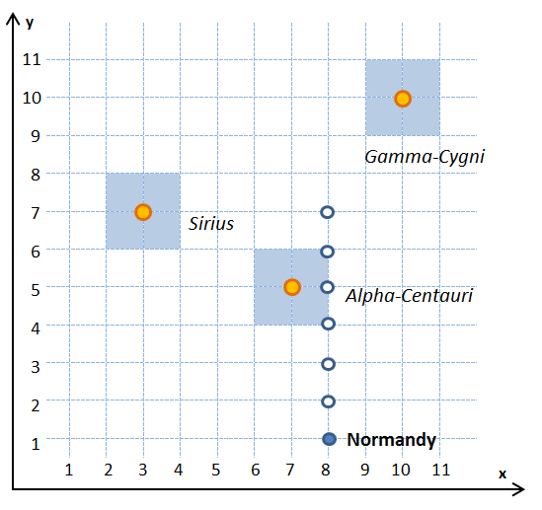

### The Normandy can only be at one location at a time. The possible locations are "<star1 name>", "<star2 name>", "<star3 name>" and "space". In other words, if the Normandy is in the range of Alpha-Centauri, her location is "alpha-centauri". If she's not in the range of any star system, her location is just "space".

Star systems will **NOT** overlap.

*Example*: the Normandy's initial location is at (8, 1). There, she in outside of any star system, so she is in "space". She starts moving up and her next two locations at (8, 2) and (8, 3) are again in "space". After that, at (8, 4), (8, 5), (8, 6) she is in the range of Alpha-Centauri – therefore, she is in "alpha-centauri". Her final location (8, 7) is outside any star, and her location is "space".

### Input

The input is passed to the first JavaScript function found in your code as **array of several arguments**:

* The first arguments will contain each star system's name and coordinates in the format "<**name**> <**x**> <**y**>", separated by spaces. The **name will be a single word, without spaces**.
* The fourth argument will contain the Normandy's initial coordinates in the format "<**x**> <**y**>", separated by spaces.
* The fifth, last argument, will contain the number **n** – the number of turns the Normandy will be moving.

The input data will always be valid and in the format described. There is no need to check it explicitly.

### Output

The output consists of **n + 1** lines – the Normandy's **initial** location, plus the **locations she was in during her movement**, each on a separate line. All locations must be printed **lowercase**.

### Constraints

* The grid dimensions will be no larger than 30x30.
* All star systems will be squares with a fixed size: 2x2.
* The turns will be no more than 20.
* Time limit: 0.3 sec. Memory limit: 16 MB.

### Examples

|  |  |  |  |  |
| --- | --- | --- | --- | --- |
| **Input** | **Output** |  | **Input** | **Output** |
| Sirius 3 7  Alpha-Centauri 7 5  Gamma-Cygni 10 10  8 1  6 | space  space  space  alpha-centauri  alpha-centauri  alpha-centauri  space | Terra-Nova 16 2  Perseus 2.6 4.8  Virgo 1.6 7  2 5  4 | perseus  virgo  virgo  virgo  space |